

**UNIVERSITI TUNKU ABDUL RAHMAN**

**LEE KONG CHIAN FACULTY OF ENGINEERING**

**AND SCIENCE**

**MAY 2016 TRIMESTER**

**UECS2103 OPERATING SYSTEMS**

Course : Bachelor Of Science (Hons) Software Engineering

Lecture : L1

Lecturer’s Name : Mr.Sor Kean Vee

|  |  |  |  |
| --- | --- | --- | --- |
| **No.** | **Name** | **Student ID No.** | **Year & Sem** |
| 1. | Ching Ming Siew | 1401239 | Y2S1 |
| 2. | Choy Yi Zhen | 1404206 | Y2S1 |

PART A1

sem pile_empty = 0, fuel_empty = 0, pile_fill = 0, fuel_fill = 0;

int found = 0, pile = 0, fuel = 0;

workers() {

do {

if(pile < 2)

semSignal(pile_empty);

if(fuel < 4)

semSignal(fuel_empty);

semWait(pile_fill);

semWait(fuel_fill)

do {

Display “Searching...";

for(int i = 0; i < PILES_CONSUMED; i++)

semWait(pile);

for(int j = 0; j < FUELS_CONSUMED; j++)

semWait(fuel);

found = isFound();

Display found;

if(found == 8)

Display "Mineral found.";

else

Display "Mineral not found.";

} while(found != 8 && pile >= 2 && fuel >= 4);

} while(found != 8);

}

pile_supplier() {

do {

semWait(pile_empty);

Display "Delivering piles.";

for(int i = 0; i < PILES_DELIVERED; i++)

semSignal(pile);

semSignal(pile_fill);

} while(found != 8)

}

fuel_supplier() {

do {

semWait(fuel_empty);

Display “Delivering fuels.”;

for(int i = 0; i < FUELS_DELIVERED; i++)

semSignal(fuel);

semSignal(fuel_fill);

} while(found != 8);

}

PART A2

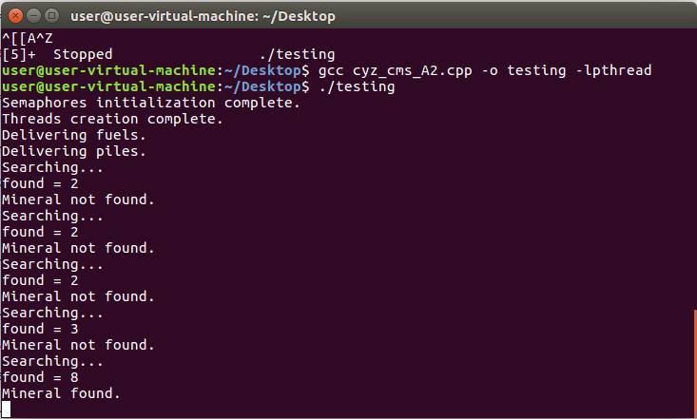

PART B

**Real time task 1**: On the alarm when smoke or fire has been detected.

Functionality: This task is to ensure the safety of people in the building. The alarm alert people in the building that there are smoke or fire detected in the building, so that people will leave the building as soon as possible before getting hurt.

Type: Hard real time task

Consequence of failure: The alarm will not be on when there is fire in the building. The dangerous situation will be known only when people saw the smoke or fire. This delay the evacuation of people in the building, increases the causalties and damages of the building.

**Real time task 2**: CCTV record the situation in lifts and car park.

Functionality : This task is to enable the security guard to monitor the situation of car park and lifts. The video recorded by CCTV is displayed on security room monitors. If there are any incident or problem occur, the security guard can see it through the monitor and provide help imediately.

Type : Soft real time task

Consequence of failure: The CCTV may not working or the video will not be display on the monitor. Security guard cannot monitor the car park and lift situation effectively. More man power is needed to patrol around the area. If any incident happens, there are no video recorded as evidence.

**Real time task 3**: Controlling the flow of electricity.

Functionality: The Power Management System is taking control the electrical system. The priority task of the system is always making sure that the electrical system is assigning and controlling electricity safe and efficient to electricity consumers. It also avoids power consumption to be larger than power production by automatic start and stop consumers.

Type : Soft real time task

Consequence of failure: The power production broke down totally can cause widespread blackout.